NOTTINGHAM TRENT UNIVERSITY
SCHOOL OF SCIENCE AND TECHNOLOGY

Project Title
Evaluating Biophilic Intervention for Mental Wellbeing

Author
Tobenna Nwafor

Award
BSc (Hons) Computer Science (Games Technology)

Project report on part fulfilment of the requirements for the degree of Bachelor of Science with Honours

I hereby declare that I am the sole author of this report. I authorize Nottingham Trent University to lend this report to other institutions or individuals for the purpose of
scholarly research.
I also authorize Nottingham Trent University to reproduce this report by photocopying or by other means, in total or in part, at the request of other institutions or individuals for
the purpose of scholarly research.

Signature: ________________
Date: __4/30/2026__

ABSTRACT

Urban and digitally mediated lifestyles can reduce routine access to nature, which is associated with increased stress and reduced wellbeing. Biophilic design integrates natural elements into built environments and has been linked to psychological benefits such as reduced stress and improved mood. This project investigates whether immersive virtual reality (VR) can deliver comparable biophilic benefits by simulating natural environments in a controllable and accessible way. The work designs and prototypes having contrasting VR scenes, an icy (Arctic) setting and a domed garden
(MYFYP) using Unreal Engine with OpenXR-compatible PCVR (Meta Quest 2, Air Link). Participant responses (N = 15 convenience sample) obtained from post-session PSS-10, PANAS-style affect scales, and Coospo chest strap heart rate monitor summarized under a six-minute continuous exposure workflow (no pre-exposure psychometrics), with transparent engineering limitations documented for streaming and interaction bugs.

The outcome is primarily feasibility and pilot-level evidence for short-session affect and stress self-reports alongside a reproducible data pipeline, rather than clinical therapeutic proof. Limitations include fixed exposure order, composite post-session measurement, tethered-streaming artefacts, brevity, and non-clinical recruitment.

ACKNOWLEDGEMENTS

I would like to thank my project supervisor, James Lewis, for guidance and feedback throughout the project. I also thank the participants who volunteered their time to take part in the evaluation study, and the School of Science and Technology for providing access to software and facilities.

Table of Contents
CHAPTER 1: INTRODUCTION 9
1.1 Introduction 9
1.2 Problem statement and motivation 10
1.3 Project context (why Unreal Engine + OpenXR) 11
1.4 Intended users and use cases 12
1.5 Assumptions and constraints 12
1.6 Aim and objectives 13
Aim. 13
Objectives (SMART). 13
1.7 Scope and boundaries 13
1.8 Research questions 14
1.9 Contributions 14
1.10 Ethical framing and non-clinical positioning 15
1.11 Chapter overview 15
CHAPTER 2: CONTEXT 15
2.1 Introduction 15
2.2 Biophilic design: definitions and principles 16
2.2.1 Biophilic patterns relevant to VR 17
2.3 Why nature exposure can reduce stress (theoretical mechanisms) 17
2.3.1 Attention Restoration Theory (ART) 18
2.3.2 Stress Reduction Theory (SRT) 18
2.3.3 Control, predictability, and agency 19
2.4 Virtual reality for wellbeing and therapy 19
2.4.2 The role of presence and immersion 20
2.5 Challenges and limitations of VR interventions 20
2.5.1 Cybersickness and measurement confounds 20
2.5.2 Hardware and environmental variability 21
2.6 Measuring stress and affect (PSS, PANAS, heart rate) 21
2.6.1 Rationale for combining subjective and physiological measures 21
2.6.2 Practical considerations for PSS and PANAS administration 22
2.6.3 Interpreting heart-rate data in short sessions 22
2.7 Related work: VR nature experiences and relaxation systems 23
2.7.1 Commercial landscape (brief overview) 23
2.7.2 Academic landscape (brief overview) 23
2.8 Gap analysis and rationale 23
2.9 Design variables in VR nature experiences 24
2.10 Technical context: OpenXR and cross-device VR 25
2.11 Ethical and legal context for biometric and wellbeing data 26
2.12 Critical synthesis: what the literature implies for this project Across biophilic design and VR wellbeing research 26
2.13 Summary 27
CHAPTER 3: NEW IDEAS 27
3.1 Introduction 28
3.2 Stakeholders and user needs 29
3.3 Requirements 29
3.3.1 Initial plan (proposal / coursework template) 29
3.3.2 Final implementation (constraints-driven delivery) 30
3.3.3 Requirements prioritization (applied to finals) 31
3.3.4 Use cases 32
3.4 Environment design goals: initial archetypes versus final UE scenes 32
3.4.1 Initial biophilic archetypes (conceptual blueprint) 32
3.4.2 Final UE5 implementation (evaluation-facing) 33
3.5 Interaction design 33
3.5.1 Minimizing demand characteristics 33
3.5.2 Accessibility considerations 34
3.6 Evaluation methodology and protocol 34
3.6.1 Study design details (initial aspirations vs final executed structure) 36
3.6.2 Variables and hypotheses (initial factorial intent vs empirical scope) 37
3.6.3 Inclusion/exclusion criteria and safety 37
3.6.4 Pilot testing plan versus executed pilot cohort 38
3.7 Data management plan 38
3.7.1 Data schema: initial aspiration versus final spreadsheet 38
3.7.2 Data retention and access control 38
3.8 System design overview 39
3.8.1 Architecture (conceptual): initial plan versus final build 39
3.9 Risks and mitigation 39
3.9.1 Participant safety and comfort risks 39
3.9.2 Data capture and measurement risks 40
3.9.3 Technical and implementation risks 41
3.9.4 Recruitment and operational risks 42
3.9.5 Privacy, ethics, and data governance risks 42
3.9.6 Schedule and project-delivery risks 43
CHAPTER 4: IMPLEMENTATION OR INVESTIGATION 43
4.1 Introduction 44
4.2 Tools and platforms 44
4.3 Project structure and configuration 44
4.3.2 VR and rendering configuration rationale 45
4.3.3 Map organization 46
4.4 Environment implementation 46
4.4.1 Asset sourcing and licensing 46
4.4.2 Lighting and atmosphere 47
4.4.3 Audio implementation 47
4.4.4 Comfort constraints (performance and motion) 48
4.4.5 Experimental environments administered to participants 48
4.4.6 Engineering artefacts, mitigation, and carry-over during participant testing 51
4.5 Interaction and navigation implementation 55
4.5.1 Locomotion choice 55
4.5.2 Session flow UI 55
4.5.3 Safety affordances 56
4.6 Data capture and export implementation (planned and implemented) 56
4.6.1 Session identifiers 57
4.6.2 Event timeline 57
4.7 Testing and verification 57
4.7.1 Functional testing 57
4.7.2 Comfort and performance testing 58
4.7.3 Pilot testing outcomes (implemented changes) 58
4.8 Project management and timetable 59
CHAPTER 5: RESULTS AND DISCUSSION 59
5.1 Introduction 59
5.2 Participants and procedure 60
5.2.1 Recruitment and sampling 60
5.2.2 Ethics and consent 63
5.2.3 Procedure (final protocol) 63
5.2.4 Protocol parameters (final protocol) 68
5.2.5 User testing dataset (final protocol) 69
5.3 Quantitative results 70
5.3.1 Scoring 71
5.3.2 Analyses used for the final protocol dataset 71
5.3.3 Reporting tables (final protocol results) 71
5.3.4 Reporting figures 73
5.3.5 Interpretation of quantitative results (linked to literature) 74
5.4 Qualitative feedback and observations 75
5.4.1 Structured thematic condensation 75
5.5 Discussion 77
5.5.1 Relating empirical patterns to cited literature 77
5.5.2 Limitations: what conclusions are and are not supported 77
5.5.3 Implications for future iteration 78
CHAPTER 6: CONCLUSIONS AND FUTURE WORK 79
6.1 Conclusions 79
6.2 Future work 79
6.3 Legal, Social, Ethical and Professional Issues 80
6.4 Synoptic reflections 81
REFERENCES 82
APPENDICES 83
APPENDIX A — Project planning evidence 83
APPENDIX B — Study materials 85
APPENDIX C — Data schema and anonymization 87

LIST OF FIGURES AND TABLES

LIST OF FIGURES

Figure 1: Figure 5.0: Final protocol session chronology (6 minutes cumulative VR exposure). 67
Figure 2 • Figure 5.1: distribution of post-session PSS totals 74
Figure 3 • Figure 5.2a: distribution of PA totals 75
Figure 4• Figure 5.2b: distribution of NA totals 76
Figure 5• Figure 5.3: distribution of mean HR (bpm) 77
Figure 6• Figure 5.4: distribution of dizziness ratings 78

LIST OF TABLES

Table 1Initial plan versus final implementation (summary) 31
Table 2 Requirements prioritization (applied to finals) 34
Table 3 Use cases 35
Table 4 Final analysis executed (versus initial statistical ambition) 38
Table 5: Comparative description of immersive stimuli by condition. 51
Table 6 Table 4.6: Engineering artefacts, mitigation posture, and implications for interpretation 54
Table 7 Table 5.0: Participant characteristics 63
Table 8 Table 5.2: Participant demographics summary (N = 15) 64
Table 9 Table 5.4: Chronometric structure and instrumentation locus 68
Table 10 Table 5.1: User testing summary (N = 15) 71
Table 11 Table 5.3: Post-exposure questionnaire and comfort summary (N = 15) 73
Table 12 Table 5.5: Thematic condensation of post-session debrief summaries (N = 15) 77
Table 13 The planning document sets out a 7 month timeframe and an indicative schedule: 84
Table 14 Dataset column dictionary (canonical CSV) 88

CHAPTER 1: INTRODUCTION

Introduction

Recent societal shifts toward urbanization and technology-centric living have reduced everyday contact with natural environments for many people. A growing body of research suggests that exposure to nature or even to nature-like cause can reduce stress and improve mental wellbeing. Biophilic design formalizes this idea by integrating natural elements into built environments, producing measurable psychological benefits (e.g., mood improvement, cognitive restoration, reduced stress) (Gillis and Gatersleben,
2015; Kellert, 2008).

Virtual reality (VR) offers an alternative approach when direct access to nature is limited.
VR can present controlled, repeatable, and immersive scenes that simulate natural spaces. Prior work indicates that VR-based interventions can be effective for mental health applications and can provide scalable and accessible experiences (Park et al.,
2019; Bell et al., 2024). However, the effectiveness of VR-delivered biophilic environments depends on factors including environmental fidelity, comfort, interaction
design, and evaluation methodology.

This project develops VR biophilic environments and a study protocol to evaluate participants subjective and physiological responses. The report is structured to follow a standard final year format (Title Page; Abstract; Acknowledgements; Contents; List of Figures and Tables; Chapters 1-6; References; Appendices).

1.2 Problem statement and motivation

In many urban settings, routine exposure to natural spaces is limited by time, geography, weather, mobility, and cost. At the same time, stress and mental wellbeing have become prominent public health concerns. Physical biophilic interventions can be effective but may be expensive or inaccessible. A VR-based alternative could offer controlled exposure to biophilic cues in a repeatable and scalable format, suitable for
non-clinical wellbeing contexts.

Beyond simple access constraints, nature exposure is often unevenly distributed. People in dense housing, those with limited transport options, or those with caregiving responsibilities may have fewer opportunities to visit restorative green/blue spaces. In these cases, a dose of nature becomes a practical issue: even if nature is beneficial, it may not be reachable when it is needed. A short VR session (e.g., 5-15 minutes) could be delivered in a controlled indoor location such as a university lab, community setting, or workplace wellbeing room, provided that the experience is comfortable and
ethical to administer.

The challenge is that VR nature can be implemented in many ways, ranging from photorealistic 360° video to stylized real-time 3D scenes. These design choices affect presence (the sense of being there), cybersickness risk, and interpretability of outcomes. Additionally, evaluation in a final year project must be feasible: the design must support quick onboarding, repeatable exposure, and straightforward data capture without clinical claims. For these reasons, the project focuses on producing a demonstrable prototype and a rigorous evaluation plan using validated measures (PSS
and PANAS) alongside heart-rate monitoring.

1.3 Project context (why Unreal Engine + OpenXR)

Unreal Engine is selected because it supports real-time rendering, physically based lighting, spatial audio, and modern VR pipelines. These features are useful when attempting to create environments that feel coherent and calm. OpenXR is used as the VR runtime interface because it is a vendor-neutral standard that supports multiple headsets and tracking capabilities. This aligns with an academic evaluation context where hardware availability may change and where portability across devices is
beneficial.

1.4 Intended users and use cases

This project is not a clinical product. Instead, it is an exploration of feasibility and
potential:
- University research/lab use: A short-session experience that can be administered
consistently during participant testing.
- Non-clinical wellbeing demonstration: A prototype that shows how VR could
deliver nature-like cues in a controlled setting.
- Foundation for future work: A structured code/content base and study protocol that could later be expanded into longitudinal or adaptive interventions (explicitly out of scope here).

1.5 Assumptions and constraints

The project makes several practical assumptions:
- Participants are adults able to give informed consent and withdraw at any time.
- Exposure sessions are short enough to reduce fatigue and cybersickness risk.
- Heart-rate data is collected using a consumer chest-strap sensor (Coospo selected over Polar-H10 based on cost) and treated as supportive
rather than definitive evidence.
Constraints include time-bound development, limited access to specialist clinical infrastructure, and the need to keep project simple enough to run reliably.

1.6 Aim and objectives

Aim.
Evaluate human responses to VR biophilic environments designed to promote mental wellness and reduce stress, and assess their potential for psychological
rehabilitation support in non-clinical contexts.

Objectives (SMART).

- Develop multiple VR environments (e.g., arctic, garden) that emulate natural spaces and incorporate calming stimuli informed by literature.
- Measure impact using validated psychological tools: PSS and PANAS, plus heart
rate as a biometric indicator.
- Conduct a monitored study with 15 participants of varied ages/backgrounds to support diversity of results.
- Ensure relevance to current mental-health needs with a cost-effective, accessible
alternative to physical biophilic installations.
- Complete development, evaluation, analysis, and reporting within a
7-month timeframe.

1.7 Scope and boundaries

The scope is a VR prototype consisting of multiple nature-inspired environments, interaction/behavioral tracking (e.g., gaze/movement), and a measurement workflow
for PSS/PANAS and heart rate.

Out of scope (explicitly excluded): acquisition of VR hardware, longitudinal studies beyond 7 months, clinical trials/medical certification, commercial platform integration, multiplayer features, AI-driven personalization, real-time biofeedback adaptation, and
mobile versions of VR experience.

1.8 Research questions

- RQ1: Can VR biophilic environments produce measurable short-term
improvements in perceived stress and affect?
- RQ2: Which environment characteristics (audio, visual composition, interactivity, comfort settings) are most associated with positive participant responses?
- RQ3: What constraints and risks arise when collecting psychological and
biometric data in a student-led, non-clinical study?

1.9 Contributions

- A VR prototype delivering multiple biophilic environments (OpenXR + Unreal Engine).
- A repeatable study protocol using PSS/PANAS and heart-rate measurement.
- A data schema and export approach suitable for subsequent statistical analysis.
- A critical discussion of limitations, trade-offs, and future research directions.

1.10 Ethical framing and non-clinical positioning

Although the project uses language associated with therapy research (stress reduction, mental wellbeing), it does not claim clinical efficacy. The evaluation is positioned as a controlled, non-clinical study to assess feasibility and short-term responses. Ethical considerations include minimizing discomfort, ensuring informed consent, protecting privacy, and providing clear withdrawal mechanisms. These considerations influence the
design of environments, interaction flow, and data collection plan.

1.11 Chapter overview

- Chapter Two reviews context and literature
- Chapter Three defines requirements, methodology, and design (New Ideas)
- Chapter Four documents implementation/investigation and project management
-Chapter Five presents results and discussion for the collected sample
- Chapter Six concludes with future work and reflections.

CHAPTER 2: CONTEXT

2.1 Introduction

This chapter provides a wider background for the project by reviewing biophilic design and wellbeing, VR interventions in mental health, and the measurement tools used to evaluate outcomes. It also identifies gaps that motivate the design and evaluation
choices made in the project.

2.2 Biophilic design: definitions and principles

Biophilic design integrates natural elements and nature-inspired patterns into built environments. Examples include vegetation, water features, natural light, views of nature, organic forms, and materials associated with natural settings. Reviews suggest links between biophilic exposure and reduced stress, improved mood, and improved cognitive functioning (Gillis and Gatersleben, 2015). Kellert (2008) provides theory and
practice guidance for translating these concepts into design.

Biophilic design is often discussed at multiple levels:
- Direct experience of nature (e.g., plants, water, sunlight, airflow, animals).
- Indirect experience of nature (e.g., natural materials, images of nature, natural color palettes, biomorphic forms).
- Experience of space and place (e.g., prospect/refuge, wayfinding cues, coherent
spatial organization that resembles natural exploration).

For a VR prototype, these levels translate into controllable design variables. For example, direct nature cues can be represented by moving foliage, animated water surfaces, and spatialized audio; indirect cues can be represented by textures/materials and lighting; and space and place can be represented by environment layout, visibility, and navigational affordances. The key question for this project is not whether biophilic principles are valuable in architecture (which is well studied), but whether a carefully designed VR experience can deliver similar short-term psychological responses
in a time-bounded evaluation.

2.2.1 Biophilic patterns relevant to VR

Several patterns are particularly applicable to VR environments:
- Visual connection with nature: obvious and sustained exposure to vegetation,
sky, and natural movement.
- Non-visual connection with nature: ambient audio (wind, water, birds), and
potentially haptic cues (controller vibration) if appropriate.
- Presence of water: water features are widely perceived as calming and provide
both audio and visual motion.
- Dynamic and diffuse light: soft lighting changes, volumetric light rays, and sky
Gradients can support a safe ambience.
- Complexity and order: environments should be rich enough to feel believable but ordered enough to avoid cognitive overload.

In VR, complexity and order is a practical performance and comfort constraint.
Dense foliage can be visually calming but expensive to render, especially on standalone devices. Therefore, the design must balance fidelity and performance while maintaining a cohesive aesthetic.

2.3 Why nature exposure can reduce stress (theoretical mechanisms)

Several theories support the link between nature cues and wellbeing. Attention restoration theory suggests nature supports recovery of directed attention through soft fascination. Stress reduction theory proposes physiological down-regulation in response to safe, non-threatening environmental cues. In practice, outcomes likely depend on individual differences, prior experiences, and the nature of exposure
(duration, context, and perceived control).

2.3.1 Attention Restoration Theory (ART)

ART proposes that modern tasks require sustained directed attention (e.g., studying, working on screens), which can become fatigued. Natural environments can engage involuntary attention in a gentle manner (soft fascination), allowing directed attention resources to recover. In practical terms, environments with slow, nondemanding motion (leaves swaying, water ripples) and coherent visual structure may
support restoration because they are interesting without requiring effortful focus.

2.3.2 Stress Reduction Theory (SRT)

SRT suggests that humans can experience a physiological shift toward relaxation when exposed to safe, non-threatening natural cues. This can manifest as reduced arousal and improved effect. In a VR context, this theory implies that scenes should prioritize cues of safety: open visibility (prospect), sheltered areas (refuge), stable lighting, and the absence of threatening stimuli (e.g., loud sudden sounds, aggressive animals, excessive
darkness).

2.3.3 Control, predictability, and agency

Both ART and SRT can be moderated by participants’ sense of control. In VR, agency is partly mediated by locomotion and interface design. If participants feel trapped or confused, stress may increase even if the environment is visually pleasant. Therefore, a key design principle is to provide simple controls, clear
onboarding, and an always-available exit.

2.4 Virtual reality for wellbeing and therapy

VR can simulate environments with high levels of immersion, potentially producing effective and physiological responses similar to real-world experiences. Research on VR therapy indicates increasing interest and evidence across mental health applications
(Park et al., 2019; Bell et al., 2024). VR’s strengths include repeatability and controllability: a participant can experience the same environment under consistent
conditions, which are valuable for evaluation.

2.4.1 VR in mental health: what is established vs what is exploratory.
The literature includes both established uses (e.g., exposure therapies for phobias) and emerging uses (e.g., relaxation, mindfulness support, and stress reduction). While some domains have clearer clinical pathways, VR nature for wellbeing often sits between entertainment and therapy. This project intentionally adopts a non-clinical framing and evaluates short-term responses using validated measures rather than
diagnostic outcomes.

2.4.2 The role of presence and immersion

Presence, the subjective sense of being in the virtual environment often mediates VR outcomes. High presence can support emotional engagement, but it can also amplify discomfort if the experience induces cybersickness. Therefore, the prototype aims to create coherent, comfortable scenes, prioritizing stability and gentle motion over
intense interactions.

2.5 Challenges and limitations of VR interventions

Key constraints include cybersickness risk, comfort and usability issues, hardware availability, and potential novelty effects. These factors can confound measurement: if an environment causes discomfort, survey responses may reflect nausea or disorientation rather than relaxation. Therefore, comfort-first interaction design and
Short, controlled sessions are crucial for this project.

2.5.1 Cybersickness and measurement confounds

Cybersickness (nausea, dizziness, eye strain) is a well-known VR risk. It can be triggered by sensory mismatch (visual motion without corresponding physical motion), low frame rates, high latency, or abrupt camera movements. If cybersickness occurs, it can overshadow any potential relaxation effect. From a research perspective, this is a confound: post-exposure PSS/PANAS responses may worsen due to discomfort rather than due to environment content. For this reason, the evaluation protocol should capture
comfort feedback and allow early termination without penalty.

2.5.2 Hardware and environmental variability

Different headsets and tracking systems can produce different experiences (field of view, weight, refresh rate, inside-out vs outside-in tracking). Even within a single lab, differences in room setup, lighting, and noise may influence participant comfort. The prototype therefore aims to be robust to small variations, and the protocol includes
consistent instructions and standardized session timing.

2.6 Measuring stress and affect (PSS, PANAS, heart rate)

The project uses validated self-report measures alongside a physiological indicator.
- PSS: measures perceived stress and is widely used for evaluating stress-related
interventions (Cohen, Kamarck and Mermelstein, 1983).
- PANAS: separates positive and negative effect and is frequently used in mood
research (Watson, Clark and Tellegen, 1988).
- Heart rate: provides a physiological correlate of arousal and stress. Literature on chest-band monitors often cites Polar-H10 as a benchmark for consumer accuracy (Polar Electro, 2020). For this project, recordings were obtained with a
Coospo Bluetooth chest-strap belt chosen because Polar-H10 was prohibitively expensive within the dissertation budget with the same interpretive
caveat: supportive triangulation only.

2.6.1 Rationale for combining subjective and physiological measures

Self-report instruments capture how participants interpret and label their internal state, while heart rate provides a physiological correlate that may reflect arousal. Neither is sufficient alone: participants may under/over-report due to demand characteristics, and heart rate is affected by many factors (fitness, caffeine, movement, anxiety about the lab setting). Combining measures provides triangulation and allows more cautious interpretation.

2.6.2 Practical considerations for PSS and PANAS administration

For short-session VR studies, questionnaires can be administered:
- Outside VR (paper or digital form), which reduces UI complexity inside VR.

PSS reverse-scoring (why it is required). The PSS includes both negatively phrased stress items (where higher responses indicate greater perceived stress) and positively phrased coping/control items (where higher responses indicate lower perceived stress). To ensure that the total score has a consistent interpretation higher total = higher perceived stress items 4, 5, 7, and 8 are reverse scored prior to summation.
Reverse scoring uses the mapping: 0 to 4, 1 to 3, 2 to 2, 3 to 1, 4 to 0. Without this step, high coping/confidence responses would incorrectly increase the stress total and
compromise comparability across participants and conditions.

2.6.3 Interpreting heart-rate data in short sessions

Heart rate can decrease during relaxation but can also increase due to novelty, discomfort, or movement. In this project, heart-rate outcomes should be interpreted as supportive evidence and reported with limitations.

2.7 Related work: VR nature experiences and relaxation systems

Commercial VR relaxation applications commonly use guided meditation, ambient soundscapes, and minimal interactions. Academic prototypes often focus on presence, restoration, and feasibility. These systems demonstrate potential but vary in transparency about evaluation quality and replicability. This project’s focus is a measurable prototype with documented procedure and analysis plan.

2.7.1 Commercial landscape (brief overview)

Common patterns in commercial products include destination environments
(beaches, forests), guided breathing prompts, and short experiences targeted at relaxation. These can be effective for user satisfaction but do not necessarily provide scientifically interpretable outcomes. For this final-year project, commercial products function mainly as design references for comfort, onboarding, and ambience rather than as evaluation baselines.

2.7.2 Academic landscape (brief overview)

Academic work typically provides stronger evaluation methodology but may use small samples or lab-specific hardware. Findings often suggest that VR nature can improve mood and reduce stress markers, but results are heterogeneous due to differences in stimuli, duration, and measurement tools. This heterogeneity motivates the use of validated instruments and a controlled session design in this project.

2.8 Gap analysis and rationale

While literature supports both biophilic benefits and VR feasibility, there remains a need for controlled, time-bounded prototypes that (a) provide multiple environments, (b) capture measurable outcomes with validated tools, and (c) document repeatable
evaluation pipeline appropriate for a final year project. More specifically, gaps relevant to this project include:
- Evaluation consistency: Many VR wellbeing experiences lack transparent and
validated measurement.
- Repeatable environment design: Some studies use video-based stimuli that are difficult to modify; others use complex interactive scenes that add variability. This
project aims for controllable, consistent exposure scenes that still feel engaging.
- Practical data workflows: Small studies often struggle with linking session logs to survey responses in a clean, anonymized format. This project proposes a data schema
designed from the outset to support analysis.

2.9 Design variables in VR nature experiences

Although VR nature is often described as a single category, it is better understood as a set of design variables that can be tuned. These variables matter
because they influence both user comfort and the meaning of any measured effect:
- Fidelity vs stylization: Photorealistic scenes may increase perceived realism but also risk uncanny artifacts; stylized scenes can be coherent and calming if consistent.
- Interactivity: Passive viewing reduces variability, but limited interaction can
increase engagement and agency.
- Locomotion: Teleportation tends to reduce cybersickness; smooth locomotion can
increase exploration but risks discomfort.
- Audio design: Spatialized natural audio can strongly contribute to presence and
relaxation; mismatched audio can reduce believability.
- Session length: Longer exposure may increase effect size but also increases
Fatigue and sickness risk.

In this project, the environment is designed to be visually coherent and calming, with limited but meaningful interaction and comfort-first locomotion. The intention is to reduce confounds and make the session repeatable across participants.

2.10 Technical context: OpenXR and cross-device VR

OpenXR is a standard API for VR/AR that aims to reduce vendor lock-in by providing a unified interface for rendering, input, and tracking. In Unreal Engine, OpenXR is typically used through the engines XR subsystem and optional plugins for hand tracking or eye tracking depending on device support. For a final year project, OpenXR is valuable because it reduces dependence on a single vendor SDK and supports a wider range of
headsets for testing and demonstration.

From a study design perspective, cross-device variability is still a concern: different headsets have different optics, comfort, and tracking accuracy. The project therefore treats OpenXR as an enabling layer, while the evaluation protocol documents the specific
hardware used during data collection.

2.11 Ethical and legal context for biometric and wellbeing data

Because the study collects questionnaire responses about stress and affects and may include biometric heart-rate data, it must be treated as sensitive. Key principles include: - Informed consent: Participants must understand what data is collected, why it is
collected, and how it will be used.
- Data minimization: Collect only what is needed to answer the research questions. - Pseudonymization/anonymization: Store participant identifiers separately from
outcome data; report results in aggregate.
- Secure storage: Use secure university storage where possible; restrict access to
the dataset; avoid sharing raw identifiable data.
- Right to withdraw: Participants should be able to withdraw without penalty; withdrawal handling should be documented (especially what can/cannot be removed
once data is anonymized).

These constraints shape the project design (data schema, storage decisions, and export
format) described in Chapter 3.

2.12 Critical synthesis: what the literature implies for this project Across biophilic design and VR wellbeing research
A consistent message is that environment cues can influence stress and affect, but outcomes are sensitive to implementation details. For this project, the literature implies several practical designs
rules:
- Comfort and control are prerequisites; without them, any nature benefit may be
masked.
- Measures should be validated and administered consistently; otherwise, results are difficult to interpret.
- A multi-modal approach (questionnaires + physiological data) improves interpretability
but does not remove confounds.
- Short-session benefits are plausible, but long-term or clinical conclusions are not justified without larger, longitudinal studies (explicitly out of scope).

2.13 Summary

The evidence base motivates a VR biophilic prototype but highlights the importance of comfort, repeatability, and responsible data handling. These directly inform the projects requirements and design in Chapter Three and implementation in Chapter Four.

CHAPTER 3: NEW IDEAS

3.1 Introduction

This chapter describes the planned approach from the proposal and planning stage
(Arctic, Garden archetypes; pre/post questionnaires in some variants; longer exposure windows on paper) and contrasts it explicitly with what was
implemented and evaluated: two UE5 VR maps (Arctic and
MYFYP/Garden), six minutes of cumulative locomotor VR (3min + 3min, fixed
Arctic-first order), post-session questionnaires only, and ancillary heart-rate summaries (Coospo H808S) (authoritative procedural detail Chapter 5). This split avoids implying the empirical chapter measured more than was instrumented.

Initial plan versus final implementation (summary)
Table 1Initial plan versus final implementation (summary)
Topic | Initial plan / proposal-era intent | Final implemented study (this dissertation)
Scene set | Three broad biophilic archetypes (Forest, Ocean/coastal, Garden) for design exploration. | Two UE5 maps with contrasting cue density: Arctic first, MYFYP/Garden second (Chapter 4, Table 4.5).
Session flow | Coursework-style patterns: baseline, then exposure, then post-session measures. | Briefing, then 6 minutes cumulative VR (3 + 3), then post-session questionnaires once (Sections 5.2.3 to 5.2.4).
Psychometrics | Pre/post PSS and PANAS listed in requirements tables. | Post-session only after both maps (no pre-exposure baseline for PSS/PANAS).
Exposure length | Longer per-map intervals sketched in early drafts (minute-level design space). | Two maps of 3 minutes each = 6 minutes total (Table 5.1; Appendix C field duration_min).
Sections 3.3 and 3.4 describe initial design intent; Chapters 4–5 and Appendix C document what was built and measured (final implementation).

3.2 Stakeholders and user needs

Primary stakeholders include study participants and the academic supervisors assessing the work. Participants need prioritize safety, comfort, clarity of instructions, and minimal effort during exposure. Research needs prioritize repeatability, data quality, and robust
handling of sensitive information.

3.3 Requirements

This section separates requirements from the initial plan / proposal-era intent (three broad biophilic archetypes; a textbook-style flow from baseline, then exposure, then post; optional longer exposures) versus what was ultimately prioritized to deliver a runnable study (final implementation) consistent with Chapters 4–5 and Appendix C (biophilic_vr_data_entry.csv; duration_min records six minutes cumulative VR biome exposure, i.e. 3 min Arctic + 3 min MYFYP, fixed Arctic-first order).

3.3.1 Initial plan (proposal / coursework template)

Functional (planned).
- Author multiple distinct biophilic scenes exploring Forest / Ocean (coastal) / Garden motivational archetypes documented in N1205091_PPD.pdf, aligned with the literature survey direction (Chapter 2).
- A repeatable modular session scaffold (tutorial, then exposure, then measure) conducive to factorial expansion.
- Aspire, where feasible, to pair PSS and PANAS before and after VR to compute change scores (conceptually not executed in the final study due to logistical constraints described under Sections 3.7).
- Support opportunistic interaction fidelity (movement; grabbables) aligned with exploratory VR ergonomics coursework goals.
Non-functional (planned).
- Comfort-first ergonomics; repeatable instructions; ethically minimized biometric footprint; pragmatic approximately 7-month window linked to planning document Appendix A.

3.3.2 Final implementation (constraints-driven delivery)

Priorities shipped:
- Exactly two contrasting UE5 playable spaces (Arctic: low visual biophilic density; then domed horticultural MYFYP/Garden, portal-linked; Tables 4.5–4.6).
- Smooth joystick traversal locomotion, not a teleport-only minimal interaction shell because exploratory movement supported the research aims and pilot testers wanted interactables (Chapter 4).
- Post-session questionnaires only (PSS-10, PANAS, single-item comfort/presence sliders), so analysis stays at descriptive statistics and distributions rather than within-session change scores (Sections 5.2.3, 5.3).
- Coospo H808S heart-rate aggregates manually transcribed into the analysis CSV (Appendix C) after Bluetooth/skin-preparation quality checks.
- Structured anonymized n001–n015 CSV export supporting the Chapter 5 plots.
Residual non-functional: privacy-by-design spreadsheets; transparent shortcomings (streaming artefacts; unresolved grab/movement issues listed in Chapter 6).

3.3.3 Requirements prioritization (applied to finals)

Table 2 Requirements prioritization (applied to finals)
Priority tier | Implemented deliverable | Originating plan layer
Must | Runnable VR pipeline with stable locomotion/audio loops and exportable duration_min-aligned metrics | Consolidated prototyping and usability fixes (Sections 4.4.5–4.7)
Must | Participant safety messaging and investigator supervision basics | Planned non-functional baseline
Should | Comparative biome exposure plus grab affordances (exploratory logging possible) | Move from teleport-only draft to richer interaction
Won't | Real-time physiology biofeedback; longitudinal clinical RCT claims | Kept excluded per proposal Appendix A

3.3.4 Use cases

Table 3 Use cases
ID | Actor | Initial plan narrative | Final implementation behavior
UC1 | Researcher and participant | Baseline questionnaires, then long exposure, then post questionnaires | Briefing/consent, then 6-minute cumulative VR biome block, then single post questionnaires and debrief
UC2 | Researcher then analysis | Scripted multi-environment factorial exports | Pseudonymous CSV and descriptive statistics
UC3 | Assessor/demo | Walk two contrasting archetypes | Demonstration acknowledging limitations (Chapter 6)

3.4 Environment design goals: initial archetypes versus final UE scenes

3.4.1 Initial biophilic archetypes (conceptual blueprint)

Forest, Ocean/coastal, and Garden vignettes scaffold multi-sensorial biophilic dimensions from Chapter 2 (vegetation strata, water views, human-scale enclosures). Early concept boards targeted seven to ten minutes per scene—superseded when streaming/comfort pilots justified shorter slots: two three-minute biome blocks and reliable completion rates.

3.4.2 Final UE5 implementation (evaluation-facing)

The project settled on Ice Arctic versus Glasshouse Garden MYFYP (Chapter 4) because authoring time went to fidelity and interaction scripting rather than a third midpoint ocean map. Grab props/gun were mirrored across conditions so psychometrics reflected ambience differences rather than different interaction verbs.
Structural comparators:
- Harmonized biome timing so six minutes total VR is explicit (CSV duration_min matches the protocol).
- Consistent ambience layering (loop-stable ambient beds; caveats in Table 4.6).

3.5 Interaction design

Interaction shifted from teleport-first toward smooth joystick locomotion in short, timed segments, with physics distractions (balls/pins). Safety (pause/unmount; researcher-mediated stop) persisted (Sections 4.5, 5.2).

3.5.1 Minimizing demand characteristics

Participants were not told any scene “Should" reduce stress. Instructions covered safety and procedures, not expected feelings, to limit reporting what participants think researchers want.

3.5.2 Accessibility considerations

- Seated participation where possible.
- Large, high-contrast UI text in VR.
- Simple single-button confirmation.

3.6 Evaluation methodology and protocol

This section distinguishes the evaluation design in coursework templates (initial plan), often with paired pre/post questionnaires and three stylized biomes, from the delivered study (final implementation) in Chapters 4–5.
Initial plan: proposed procedure sketch
- Information and consent.
- Baseline psychometrics (PSS-10, PANAS) and optional resting physiology.
- VR exposure across longer planned per-map durations across Forest / Ocean / Garden.
- Post-session psychometrics, biometric summaries, debrief cues.
- Data export for pre-to-post delta factorial analysis.
Supporting analysis expectations included paired deltas, contrasts, optional Latin-square ordering where feasible.
Final implementation: procedure executed (Chapter 5 is authoritative)
- N = 15 participants, convenience/recruitment via social messaging.
- Fixed order Arctic then MYFYP/Garden for everyone—no crossover counterbalancing.
- No baseline PSS/PANAS; questionnaires once after about 6 minutes cumulative VR (two three-minute blocks).
- Equipment: Meta Quest 2 / Air Link at 75 Hz; joystick.
- Debrief material feeding theme summary (Table 5.5).
Inferential hypotheses needing paired within-person deltas were not testable; the thesis uses descriptive statistics and summarised debrief themes.
Final analysis executed (versus initial statistical ambition)
Table 4 Final analysis executed (versus initial statistical ambition)
Analysis tier | Planned under initial factorial ideal | Final pragmatic deliverables
Psychometrics comparable across biomes | Standard pre/post factorial split | Single post-session composites; mainly descriptive / cross-sectional
Sequence effects | Ideally counterbalanced order | Transparent fixed Arctic-first caveat (Section 5.5)
HR inference | Baseline vs exposure deltas | Coospo H808S summaries descriptive only

3.6.1 Study design details (initial aspirations vs final executed structure)

Initial aspiration design type. Documentation argued for within-subjects designs across three biomes to reduce between-person variance.
Final executed design type. Participants still experienced both biomes within one session, but one post hoc questionnaire block prevents clean attribution to each biome (order/fatigue confounds; limitation in Chapter 5).
Initial session duration sketch. Consent buffers, 5 min baselines, 7–10 min per scene, heavier questionnaires.
Final session duration. Compressed schedule: about six minutes locomotor biome exposure; Appendix C duration_min = 6 minutes cumulative (3 + 3), aligned with Table 5.1.
Templates suggested Latin-square ordering; logistics fixed Arctic then Garden traversal.

3.6.2 Variables and hypotheses (initial factorial intent vs empirical scope)

Initial factorial framing (literature-aligned; not statistically estimated here)
Distinct Forest / Ocean / Garden palettes with layered cues. A DV "wish list" included PSS, PANAS, and HR pre/post.
Final operational variables recorded
pss_total_scored_correct, pa_total_correct, na_total_correct, sliders, HR aggregates as one timepoint composites—scores cannot be pinned to one biome statistically.
Residual hypotheses as conceptual sensitivities:
- H1: Biophilic cues may co-occur with lower reported stress—compare with calm themes (Table 5.5).
- H2: PA/NA summaries (Section 5.3.3) are descriptive only (Sections 5.3–5.5).
- H3 (future): richness vs austerity as an axis for future counterbalanced designs.
Trade-offs emphasize throughput, completion, and explicit limitations (Sections 5.5, Chapter 6).

3.6.3 Inclusion/exclusion criteria and safety

Young adults, opportunistically recruited (about 19–23 years; Table 5.0). Exclude if VR contraindicated, severe motion intolerance, or other safety risks at screening/consent. Withdrawal allowed anytime; investigator monitored discomfort.
Pilot cohort (Chapter 4.7.3) sharpened safeguards before wider recruitment.

3.6.4 Pilot testing plan versus executed pilot cohort

Module guidance suggested a small pilot (about 2–5). Execution: pilot n = 3 (friends): exposed asset gaps; later iteration improved foliage/audio/interactions (Chapter 4). Main sample N = 15 used the refined build (Chapter 5).

3.7 Data management plan

To meet legal/ethics expectations:
- Pseudonymous IDs.
- Secure storage; minimize identifiers.
- Separate contacts from the analytic dataset.
- Document retention/deletion.

3.7.1 Data schema: initial aspiration versus final spreadsheet

Early drafts imagined fields like pss_pre_total, panas_post_pa, repeated passes—as in templates (initial plan, Section 3.6). Dropped once PSS/PANAS became post-session only.
Canonical dataset: Appendix C (biophilic_vr_data_entry.csv): PSS items, pss_total_scored_correct, pa_total_correct, na_total_correct, comfort sliders, HR aggregates, duration_min (6 minutes protocol; 3+3), headset_refresh_hz, participant_id e.g. n001… (post-only schema).

3.7.2 Data retention and access control

Only the researcher handle raw artefacts. Pseudonymized exports for reporting; scheduling contacts outside the CSV (Appendix C, Appendix C Section C.4). Retention as in the appendix (e.g. delete scheduling contacts after the booking window; submit-then-archive).

3.8 System design overview

Separate Unreal maps linked by portals. Initial plan: three biome archetypes; final: two shipped maps (Arctic, MYFYP/Garden).

3.8.1 Architecture (conceptual): initial plan versus final build

- Session flow. Unreal GameMode / pawn: startup, portal transitions, joystick locomotion (Chapter 4).
- Levels. Forest–Ocean–Garden concept became two authored levels with matched interactables (Table 4.5).
- Measurement. Early variants considered in-VR forms; final study used post-session paper/spreadsheet then biophilic_vr_data_entry.csv (Appendix C).

3.9 Risks and mitigation

This project involves technical, participant-safety, data-handling, and schedule risks. Because the study is non-clinical and time-bounded, mitigations prioritize participant comfort, repeatability, and data integrity over complex instrumentation.

3.9.1 Participant safety and comfort risks

- VR sickness / discomfort (nausea, dizziness, eyestrain)
  - Impact: early termination, compromised responses, ethical concern.
  - Mitigation: short exposure duration (six minutes total), comfort-first pacing, no forced camera motion, monitored sessions with researcher present, clear “stop at any time” instruction, immediate headset removal if symptoms occur, and post-session comfort questions to document issues.
- Trip / collision risk in room-scale movement
  - Impact: physical injury or equipment damage.
  - Mitigation: seated or standing-in-place participation where possible; clear play-area setup; remove obstacles; cable/space awareness; researcher supervision during the entire VR block.
- Anxiety or distress triggered by content (e.g., enclosed spaces, weapon prop, isolation themes)
  - Impact: distress, withdrawal, ethical concern.
  - Mitigation: non-clinical framing, participants can skip interaction elements, withdraw at any time, researcher checks comfort verbally, and debrief to ensure participants leave in a settled state.

3.9.2 Data capture and measurement risks

- Incomplete heart-rate capture (Bluetooth dropouts, poor skin contact, device pairing issues)
  - Impact: missing or unreliable physiological summaries.
  - Mitigation: pre-session strap fitting and connection checks, short recording window, repeatable setup procedure, and treating HR as a supportive/descriptive metric rather than primary evidence.
- Questionnaire entry errors (manual transcription, missed items, inconsistent scoring)
  - Impact: incorrect totals, analysis errors.
  - Mitigation: structured spreadsheet with fixed columns, consistent scoring rules (reverse-coded items handled consistently), sanity checks on totals, and keeping raw item responses (not only totals) to allow verification.
- Confounding from fixed order (Arctic then Garden) and single post-only measurement
  - Impact: cannot attribute effects to one biome; order/fatigue effects possible.
  - Mitigation: explicitly documented as a limitation; analysis restricted to descriptive reporting; future work section proposes counterbalancing and per-condition measurement.

3.9.3 Technical and implementation risks

- Performance instability (low frame rate, streaming artefacts via Air Link, stutter)
  - Impact: discomfort; inconsistent experience across participants; noise in responses.
  - Mitigation: performance tuning and usability testing, stable locomotion settings, conservative scene complexity, loop-stable audio, and documenting known artefacts transparently in limitations.
- Interaction regressions (e.g., grab/locomotion edge cases)
  - Impact: participant frustration, time loss, altered mood responses unrelated to environment.
  - Mitigation: constrain interaction scope to reliable mechanics, pilot testing, researcher assistance, and documenting persistent issues so interpretation remains honest.

3.9.4 Recruitment and operational risks

- Recruitment shortfall
  - Impact: low statistical value, insufficient evidence.
  - Mitigation: convenience recruitment via social channels, short session length, simple eligibility, and scheduling flexibility.
- No-shows / time overruns
  - Impact: reduced sample and schedule pressure.
  - Mitigation: short, repeatable session script; buffer time between sessions; clear pre-session instructions.

3.9.5 Privacy, ethics, and data governance risks

- Collection of identifiable information (e.g., phone numbers for scheduling)
  - Impact: privacy breach risk; ethical non-compliance.
  - Mitigation: keep any scheduling details outside the research dataset; pseudonymous IDs in analysis files; restrict access to raw artefacts; delete scheduling details after the booking window; report only aggregate results.
- Accidental sharing of raw datasets
  - Impact: confidentiality breach.
  - Mitigation: store files in a controlled location, limit sharing to supervisor/assessment needs, and use anonymized exports only for figures/tables.

3.9.6 Schedule and project-delivery risks

- Scope creep (attempting three environments + full pre/post + telemetry)
  - Impact: unfinished prototype or incomplete write-up.
  - Mitigation: MoSCoW prioritization, shipping two environments with a stable pipeline, and deferring advanced features (counterbalancing, richer telemetry, biofeedback) to future work.

CHAPTER 4: IMPLEMENTATION OR INVESTIGATION

4.1 Introduction

This chapter documents what was built (or investigated), how it was built, and how project planning and testing were carried out to ensure a disciplined development
process.

4.2 Tools and platforms

Development engine. Unreal Engine 5 was used to build the environments, implement interaction, and support VR rendering and level transitions.
VR runtime. OpenXR was used as the VR runtime interface to support broader headset compatibility and reduce dependence on a single vendor SDK.
Measures. The evaluation used post-session PSS-10 and PANAS-style affect measures, alongside supportive heart-rate summaries captured using a Coospo chest-strap sensor during field sessions. The Polar H10 was not adopted due to budget constraints.
Analysis. Results were analyzed using descriptive statistics (spreadsheet and/or Python). Figures used in Chapter 5 are stored under the figures/ folder in the project workspace.

4.3 Project structure and configuration

The prototype is implemented primarily using Unreal Engine’s Blueprint system to keep iteration time low and reduce compilation overhead during rapid prototyping. Blueprints are appropriate for a final-year prototype because they enable fast experimentation with interaction flow, UI, and level transitions, while still supporting structured logic via Unreal’s standard patterns (e.g., GameMode, GameInstance, and Actor Blueprints).
4.3.1 Repository/project organization
The project follows Unreal’s standard directory structure:
- Content/ contains maps (levels), assets, and Blueprints.
- Config/ contains engine and project settings that affect VR rendering and runtime behavior.
Within Content/, environments are organized as separate maps so each scene can be loaded independently. This supports repeatable exposure timing and reduces the chance of cross-environment state leaking into a session.

4.3.2 VR and rendering configuration rationale

VR imposes strict performance constraints: low frame rate and high latency can cause discomfort and can compromise the validity of evaluation results. For this reason, the project prioritizes:
- Stable frame time over maximum visual fidelity.
- Comfort-first camera behavior, avoiding forced camera motion.
- Forward rendering and MSAA were appropriate for VR clarity (particularly where TAA can introduce blur).
- Instanced stereo / Multiview options were supported to reduce rendering cost.

The project is configured to start directly in VR, so participants do not experience inconsistent desktop-to-VR transitions at the beginning of the session.

4.3.3 Map organization

The system uses a hub-and-environments structure:
- A default entry map for instructions, control familiarization, and initial setup.
- Dedicated environment maps for the biophilic scenes.
This separation supports controlled exposure timing and reduces cross-environment state carry-over between scenes, improving repeatability during participant testing.

4.4 Environment implementation

Each environment is implemented as an Unreal level that includes:
- environment geometry and foliage/water assets,
- a consistent spawn and entry area,
- ambient audio sources (looped, low variance),
- lighting and post-processing tuned to reduce harsh contrast, flicker, and distraction.

4.4.1 Asset sourcing and licensing

Assets may be sourced from Unreal Marketplace/Fab or created/modified within the project. For completeness, this section documents:
- asset pack name and source,
- license terms (e.g., Marketplace/Fab license),
- modifications performed (materials, LODs, scaling, color grading, placement).
Assets used in this project were sourced primarily from Fab and Quixel Megascans under standard personal-use terms. Assets were imported into Unreal Engine and adjusted as needed (e.g., scaling, placement, and material parameter tweaks) to support scene composition and VR performance constraints.

4.4.2 Lighting and atmosphere

Lighting was tuned for comfort and coherence:
- avoid rapid exposure changes and flickering,
- avoid extreme bloom or flashing highlights,
- use soft sky lighting and gentle volumetric effects where performance allows.
Time-of-day choices were selected to support calm, readable scenes and consistent visibility during the short, timed exposure.

4.4.3 Audio implementation

Audio is a key contributor to perceived calm and presence. The implementation uses:
- looped ambient tracks (e.g., wind, water, foliage movement),
- spatialized one-shot sounds sparingly (e.g., distant birds) to avoid startling participants,
- consistent loudness across environments to reduce measurement confounds.

4.4.4 Comfort constraints (performance and motion)

Environment complexity is constrained to protect comfort and performance:
- limit overdraw from dense alpha foliage layers,
- use LODs and impostors where appropriate,
- avoid heavy post-processing that increases GPU cost.
Locomotion is implemented in a controlled and time-bounded way; the final protocol uses smooth joystick locomotion, with short exposure duration and comfort monitoring.

4.4.5 Experimental environments administered to participants

Two immersive levels authored in Unreal Engine 5 were evaluated under the final protocol in a fixed order (Arctic, then MYFYP/Garden). Locomotion used smooth joystick thumbstick traversal. Interaction affordances were intentionally overlapped across conditions: the same tabletop props (bowling pins, baseballs, and a handheld prop used to apply impulses) were used to maintain comparable motor familiarity. This was intended to ensure that differences in ambience and cue density, rather than differences in interaction mechanics, provided the main contrast between maps.
Transition between environments used paired portal actors after each timed block. Each map was presented for approximately three minutes, for a total of six minutes cumulative exposure.
Table 4.5: Comparative description of immersive stimuli by condition.
Caption: Observable composition of each environment as experienced by participants. This table describes the implemented stimuli and does not claim equivalence to real-world outdoor environments.
Table 5: Comparative description of immersive stimuli by condition.
Design dimension | Arctic (cold / austere biome) | Garden / MYFYP (domed horticultural biome)
Spatial frame and vista | Large icy enclosure with ice ridges and distant mountain silhouettes. A frozen lake provides a dominant planar landmark. Set dressing includes a stationary vehicle, basic seating and tables, and a small campfire area, producing a sparse, lightly inhabited feel. | Enclosed garden precinct under a translucent dome. Perimeter wall reinforces refuge and containment. Paved circulation with benches, layered vegetation, and ornamental stonework.
Visual biophilic and material cues | Predominantly snow, ice, rock, and metal; negligible living vegetation by design to reduce biophilic complexity relative to the garden. | Multiple vegetation strata (trees, ground cover, planted clusters). Water features (e.g., fountain) add an aqueous cue within real-time performance limits.
Object ecology and repeatable props | Tabletop props (pins, baseballs) and the handheld impulse prop are present to support comparable interactions. | Equivalent prop placements preserve parity; additional ornamentation does not introduce new required interactions.
Soundscape (design intent) | Cold-climate ambience (wind/snow layers) with an exposed tonal character; loop stability verified prior to participant sessions. | Leaves/wind and water cues (fountain turbulence) provide richer restorative audio layering.
Locomotion and affordances | Smooth joystick locomotion. Props can be lifted/thrown where authored; portals provide transition to the next map in the fixed protocol order. | Same locomotion. portals allow transition without making return visits mandatory within the timed window.
Methodological rationale (contrast) | Botanic salience intentionally suppressed while keeping locomotion and props comparable. | Increased vegetation and water cues, intended to raise biophilic cue density while keeping interaction mechanics broadly comparable.
Narrative elaboration. In the Arctic scene, participants typically explored the frozen lake area, inspected set dressing (vehicle and campfire area), and interacted with tabletop props. In the garden scene, participants tended to follow perimeter paths toward the fountain, with attention drawn by vegetation movement and water audio. Any distant-detail softness (e.g., grass LOD) is attributed to VR performance constraints and streaming limits rather than intended design.

4.4.6 Engineering artefacts, mitigation, and carry-over during participant testing

Table 4.6: Engineering artefacts, mitigation posture, and implications for interpretation.
Caption: Technical issues observed during prototyping and participant sessions, with remediation status at the time of testing.
Table 6 Table 4.6: Engineering artefacts, mitigation posture, and implications for interpretation
Artefact cluster | Manifestation | Mitigation | Status at participant testing | Implication
Garden spawn / wall collision | Player start misalignment against oversized collision could stall movement shortly after spawn. | Collision simplification and channel tuning. | Mostly resolved; rare edge cases possible. | Adds noise to comfort/presence without clear directional bias.
Procedural foliage placement | Spawner failed to find authoritative ground collisions, producing sparse patches. | Align traces and collision channels to landscape. | Resolved. | Restores intended vegetation cue density.
Distant lawn rendering | Grass LOD shimmer or harsh silhouettes at distance. | LOD bias adjustments within frame budget. | Partially mitigated. | May contribute to debrief reports of blur/softness.
Ambient looping integrity | Ambient tracks stopped mid-session in early builds. | Correct loop settings and authoring checks. | Resolved. | Stable ambience improves comparability.
Audio cold-start | Occasional silent playback after launch until restart. | Pre-session audio check gate. | Sessions started only after audio verified. | Operational overhead, not a content confound once audio is present.
Streaming throughput (Air Link) | Tearing/frame pacing artefacts during streaming. | Scalability tuning and quality presets. | Not fully resolved. | Comfort/presence measures may reflect hardware/streaming limits as well as scene content.
Grab-hold locomotion regression | Forward translation degraded while holding certain props. | Debugging deferred due to time constraints. | Persists intermittently. | Discomfort/frustration may cluster during interaction-heavy moments.
HR acquisition (chest strap) | Unstable readings without adequate skin contact/prep. | Electrode readiness checklist. | Resolved for analyzable windows. | HR summaries depend on successful capture window.
Grab pipeline fragility | Interaction components can be sensitive to blueprint changes. | Stabilized via template-consistent grab patterns. | Stable overall; occasional physics edge cases possible. | Supports parity intent but cautions interpretation of rare anomalies.
For discussion linkage (streaming artefacts, post-only questionnaires, fixed sequence, convenience sampling), see Section 5.5 and Chapter 6.

4.5 Interaction and navigation implementation

Interaction is intentionally minimal to reduce confounds and keep the experience accessible to participants with varied VR familiarity.

4.5.1 Locomotion choice

Smooth joystick locomotion is used to allow continuous exploration. Because smooth locomotion can increase cybersickness risk, exposure is kept short and comfort indicators (nausea, dizziness, eyestrain) are captured immediately after VR.

4.5.2 Session flow UI

The project supports a consistent flow:
- Start screen / briefing: controls, safety, and how to exit.
- Environment sequence: the final study uses a fixed scripted order (Arctic then Garden).
- End: Timer ring confirms completion and transitions to post-session questionnaires.
If questionnaires are delivered in VR in future, UI should use large fonts, clear targets, and limited items per page to reduce cognitive load.

4.5.3 Safety affordances

Safety features include:
- immediate exit option, briefed pre session to call for immediate end if need be.
- pause and request assistance,
- reset orientation / recenter where supported,
- researcher supervision throughout.

4.6 Data capture and export implementation (planned and implemented)

The data pipeline aims to produce an analysis-ready dataset with minimal manual processing. Recommended exports:
- a summary CSV/JSON per session (questionnaire totals, exposure durations, comfort ratings),

4.6.1 Session identifiers

Each session uses:
- participant_id (pseudonymous, assigned by the researcher).

4.6.2 Event timeline

At minimum, record:
- session start time,
- environment entry and exit times,
- post-session questionnaire completion,
- session end time.
This supports alignment with heart-rate windows if recorded externally.

4.7 Testing and verification

Testing focused on correctness, comfort, and data integrity.

4.7.1 Functional testing

Key checks:
- levels load reliably,
- transitions and portals work,
- exit/pause always responds,
- questionnaire stores correct values (where applicable),
- exports are written successfully with valid identifiers.

4.7.2 Comfort and performance testing

Key checks:
- stable frame rate during typical activity,
- no forced camera motion,
- no flicker or rapid exposure shifts,
- comfortable and consistent audio.

4.7.3 Pilot testing outcomes (implemented changes)

Pilot testing with three volunteers validated that the workflow was runnable end-to-end and that the scenes delivered clear biophilic cues. Pilot feedback led to improvements including:
- increased environmental dressing (more vegetation/ground cover),
- added props (benches/tables) for coherence,
- added interaction (grab/physics objects),
- added ambient audio.
The refined prototype was then used for the main dataset reported in Chapter 5.

4.8 Project management and timetable

Project management follows the 7-month schedule defined in the planning document.
This dissertation includes:
- milestones and deliverables per month,
- contingency planning (buffer time for technical issues and recruitment),
- a risk log (e.g., cybersickness, recruitment shortfall, sensor availability).

The Gantt chart and planning evidence included in Appendix A, with summary discussion here focusing on how planning influenced implementation choices (e.g., prioritizing VR stability and data export over optional advanced features).

CHAPTER 5: RESULTS AND DISCUSSION

5.1 Introduction

This chapter reports the evaluation outcomes (N = 15) and discusses them in relation to the project aim and objectives. Results are presented as descriptive summaries of post-session measures collected after participants experienced both VR scenes in a fixed order (Arctic, then MYFYP/Garden). The chapter also includes condensed debrief observations and acknowledges engineering constraints that could influence comfort, presence, and perceived clarity (see Sections 4.4.5 to 4.4.6).
Because the protocol uses one post-session questionnaire block (no pre-exposure baseline and no per-scene questionnaires), reported psychometrics should be interpreted as responses to the combined six-minute experience, not as biome-specific effects.

5.2 Participants and procedure

This section documents recruitment, participant characteristics, consent procedures, and the final protocol used for user testing.

5.2.1 Recruitment and sampling

Participants were recruited via direct messaging in a friends’ group chat. Participation was voluntary and uncompensated. The target sample size was at least 15 participants, consistent with the project plan. Recruitment aimed to include participants from varied backgrounds, but the approach constitutes convenience sampling, which limits generalizability. The study is therefore positioned as a feasibility / pilot-level evaluation rather than a representative population study.

5.2.1a Participant characteristics (Table 5.0)

Individual-level pseudonymous characteristics are listed in Table 5.0 and summarized in Table 5.2. These characteristics are used to contextualize comfort outcomes and interpret how sample composition may limit generalization.
Table 5.0: Participant characteristics
Caption: Demographic and background characteristics of study participants (pseudonymized IDs) used to describe the sample and assess generalizability.
Table 7 Table 5.0: Participant characteristics
Participant ID | Age | Gender (optional) | Prior VR experience (None/Some/Frequent) | Vision corrected? (Y/N)
n001 | 20 | M | Some | Y
n002 | 20 | M | Some | Y
n003 | 21 | M | Some | N
n004 | 20 | M | Some | N
n005 | 19 | F | Some | N
n006 | 19 | M | Some | N
n007 | 20 | F | Some | N
n008 | 21 | F | Some | N
n009 | 22 | M | Some | N
n010 | 22 | M | Some | N
n011 | 23 | F | Some | N
n012 | 21 | M | Some | N
n013 | 22 | F | Some | N
n014 | 21 | M | Some | N
n015 | 20 | M | Some | N

5.2.1b Participant characteristics summary (Table 5.2)

Table 5.2: Participant demographics summary (N = 15)
Caption: Summary statistics describing the participant sample used for the final protocol dataset.
Table 8 Table 5.2: Participant demographics summary (N = 15)
Variable | Summary
Age (years) | Mean = 20.73, SD = 1.16; range = 19–23
Gender | M = 10, F = 5
Prior VR experience | None = 0, Some = 15, Frequent = 0
Vision corrected | Yes = 2, No = 13

Overall, the sample comprised 15 participants aged 19–23 (M = 20.73, SD = 1.16). All participants reported some prior VR experience, and two participants used vision correction. These factors are relevant when interpreting cybersickness and visual clarity responses, because first-time VR novelty and visual ergonomics can influence discomfort and affect reports.

5.2.2 Ethics and consent

Participants provided verbal consent prior to taking part, including consent for anonymized use of questionnaire responses and heart-rate summaries for this final-year project. No names were recorded; participants were assigned pseudonymous IDs (n001 to n015). Participants were informed they could stop the session at any time without penalty. Potential adverse effects (nausea, dizziness, eyestrain) were monitored during the session and recorded immediately after VR using comfort check questions.

5.2.3 Procedure (final protocol)

Sessions used a continuous VR stimulus block preceded by onboarding. PSS-10 and PANAS-style measures were not taken before VR; questionnaires were administered once after both environments to minimize interruption, keep the session short, and reduce procedural complexity.
Heart-rate capture used a Coospo chest-strap when usable. Setup required stable Bluetooth connection and adequate skin contact; the device was treated as a supportive metric rather than a primary endpoint (technical constraints discussed in Section 4.4.6).
Stepwise chronology.
- Briefing and consent: explain joystick locomotion, basic interaction (grabbing/throwing props), portal transitions, safety, and right to withdraw. Fit and prepare the chest strap where HR capture was attempted.
- Audio gate-check: confirm ambient audio is audible before starting, to avoid known “cold start” silence issues observed during development.
- VR block A: Arctic map for approximately 3 minutes (see Table 4.5).
- VR block B: immediate transition to MYFYP/Garden map for approximately 3 minutes (no scripted rest in between).
- Post-VR questionnaires: PSS-10; PANAS-style PA and NA totals; presence/comfort/sound clarity items recorded in the dataset.
- Structured debrief: brief anonymous comments recorded as researcher notes.
Interpretive note. Order was fixed (Arctic then Garden) for all participants, and psychometrics were collected once at the end. These design choices increase feasibility but limit causal attribution and biome-specific interpretation (see Section 5.5).

5.2.3a Procedure timeline (final protocol diagram)

Figure 5.0: Final protocol session chronology (6 minutes cumulative VR exposure).
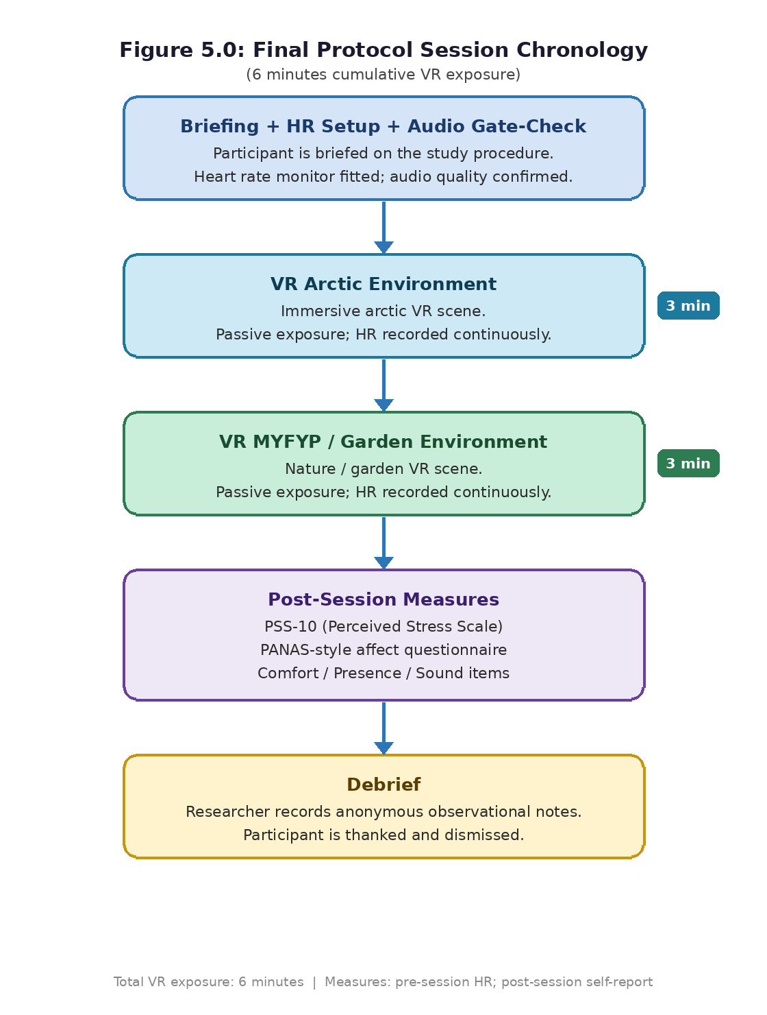
Figure 1: Figure 5.0: Final protocol session chronology (6 minutes cumulative VR exposure).

5.2.3b Chronometric instrumentation (Table 5.4)

Table 5.4: Chronometric structure and instrumentation locus
Caption: Timeline of the final protocol and where measurements were captured, highlighting threats to inference introduced by post-only measurement and fixed order.

Table 9 Table 5.4: Chronometric structure and instrumentation locus
Phase | Controlled procedure component | Capture site | Threat to inference
Briefing (+ sensor check) | Consent, control onboarding, safety, confirm audio. Strap prep if HR attempted. | No pre-VR questionnaires by design. | Reduces misunderstandings but does not remove all confounds.
VR Arctic (3 min) | Navigation and interaction within Arctic environment; immediate portal transition to second map. | HR logging where stable; psychometrics not sampled during the block. | Order confound: Arctic is always first.
VR MYFYP/Garden (3 min) | Comparable locomotion and overlapping interactions; higher biophilic cue density. | Continued HR logging where stable; still no per-map psychometrics. | Second-slot effects (novelty decay, fatigue, adaptation) not separable.
Post-session instrumentation | Questionnaires and debrief after both maps. | All psychometric endpoints occur once at the end. | No within-person pre/post deltas; biome-specific attribution not supported.

5.2.4 Protocol parameters (final protocol)

- Headset: Meta Quest 2 using Air Link (PCVR streaming).
- Refresh rate: 75 Hz (recorded per session in the dataset).
- Tracking: inside-out with Quest controllers.
- Locomotion: smooth joystick locomotion.
- Maps: Arctic first, then MYFYP/Garden.
- Timed exposure: 3 minutes + 3 minutes (6 minutes total), no instructed rest between scenes.
- Questionnaires: post-session only (PSS-10; PANAS-style PA and NA; presence/cybersickness/sound clarity items).
- Physiological monitor: Coospo Bluetooth chest strap; HR interpreted as ancillary.
- Order: fixed Arctic then Garden (order effects discussed in Section 5.5).

5.2.5 User testing dataset (final protocol)

A complete dataset was recorded under the final protocol to evidence the end-to-end testing workflow. Table 5.1 lists the recorded entries (N = 15). PSS totals use standard scoring, including reverse-scoring items 4, 5, 7, and 8 (scoring method described in Section 5.3.1).
Table 5.1: User testing summary (N = 15)
Table 10 Table 5.1: User testing summary (N = 15)
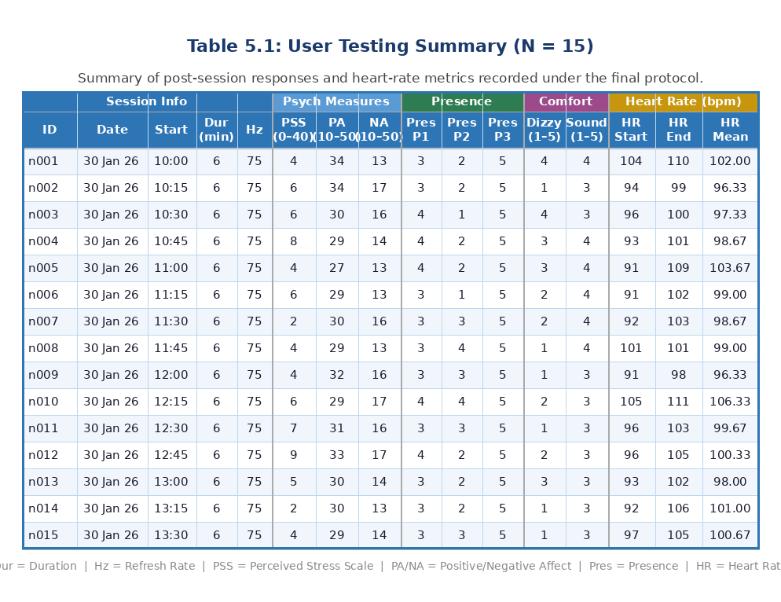

5.3 Quantitative results

This section reports descriptive results from the final protocol dataset (N = 15). In the final implementation, PSS and affect responses were collected once, immediately after participants completed both environments in fixed order. Results therefore represent post-exposure responses to the combined experience rather than per-map change scores.

5.3.1 Scoring

PSS-10. Total score follows standard PSS-10 scoring: items 4, 5, 7, and 8 are reverse-scored (0 becomes 4; 1 becomes 3; 2 stays 2; 3 becomes 1; 4 becomes 0), then all 10 items are summed (range 0–40). Higher totals indicate higher perceived stress. Because the measure was administered post-session only, only post-session totals are reported.
PANAS-style affect. PA and NA totals sum 10 positive and 10 negative items respectively (range 10–50 each). In this study they are treated as post-session composite affect descriptors.
Heart rate. HR start, end, and mean values reflect the session window captured by the chest strap. No formal resting baseline period was included, so HR is interpreted descriptively rather than as a change score.

5.3.2 Analyses used for the final protocol dataset

Because measures were collected once after the combined two-environment exposure, analysis focuses on:
- descriptive statistics (mean, SD, median, range),
- simple distributional reporting (histograms),
- comfort/presence indicators to contextualize stress and affect responses.
Confidence intervals or inferential comparisons are not emphasized due to the protocol design and small convenience sample.

5.3.3 Reporting tables (final protocol results)

Table 5.3: Post-exposure questionnaire and comfort summary (N = 15)
Caption: Descriptive statistics for post-exposure stress, affect, comfort, presence, and heart-rate summary metrics recorded under the final protocol.
Table 11 Table 5.3: Post-exposure questionnaire and comfort summary (N = 15)
Measure | Mean (SD) | Median | Range
PSS total (0–40) | 5.13 (2.00) | 5 | 2–9
PA total (10–50) | 30.40 (2.03) | 30 | 27–34
NA total (10–50) | 14.80 (1.66) | 14 | 13–17
HR mean (bpm) | 99.80 (2.70) | 99.00 | 96.33–106.33
Presence P1 (“really there”, 1–5) | 3.33 (0.49) | 3 | 3–4
Presence P2 (believable, 1–5) | 2.40 (0.91) | 2 | 1–4
Presence P3 (attention, 1–5) | 5.00 (0.00) | 5 | 5–5
Cybersickness C2 (dizzy, 1–5) | 2.07 (1.10) | 2 | 1–4
Sound clarity A1 (1–5) | 3.40 (0.51) | 3 | 3–4

5.3.4 Reporting figures

Figures were generated from the final dataset and stored under figures/. Recommended reporting set:
- Figure 5.1: distribution of post-session PSS totals
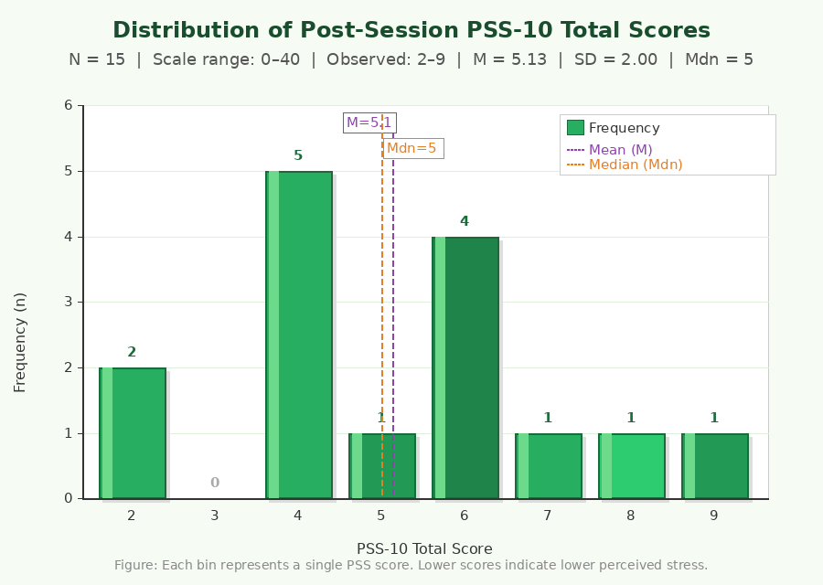
Figure 2 • Figure 5.1: distribution of post-session PSS totals
- Figure 5.2a: distribution of PA totals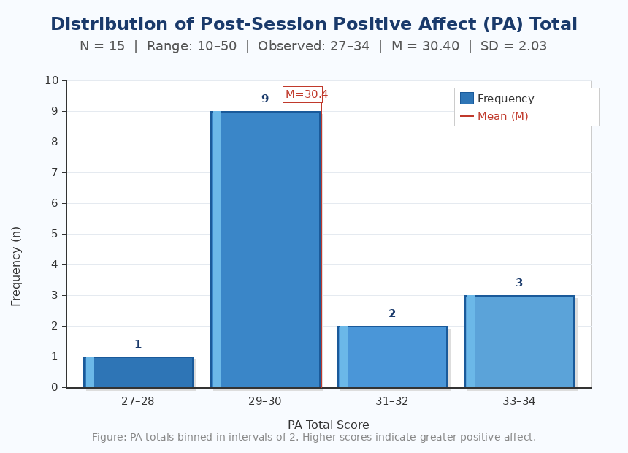
Figure 3 • Figure 5.2a: distribution of PA totals

- Figure 5.2b: distribution of NA totals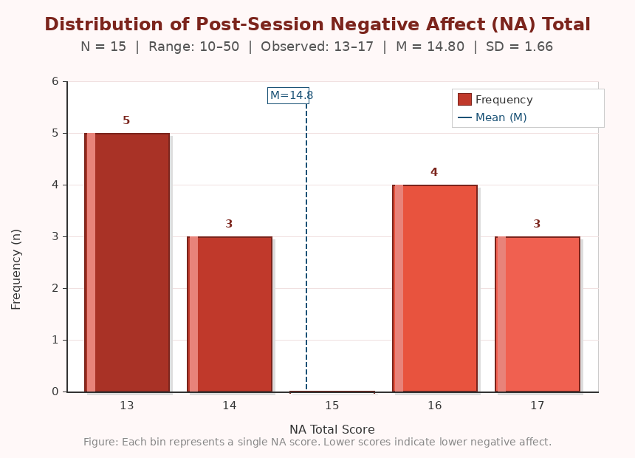
Figure 4• Figure 5.2b: distribution of NA totals

- Figure 5.3: distribution of mean HR (bpm)
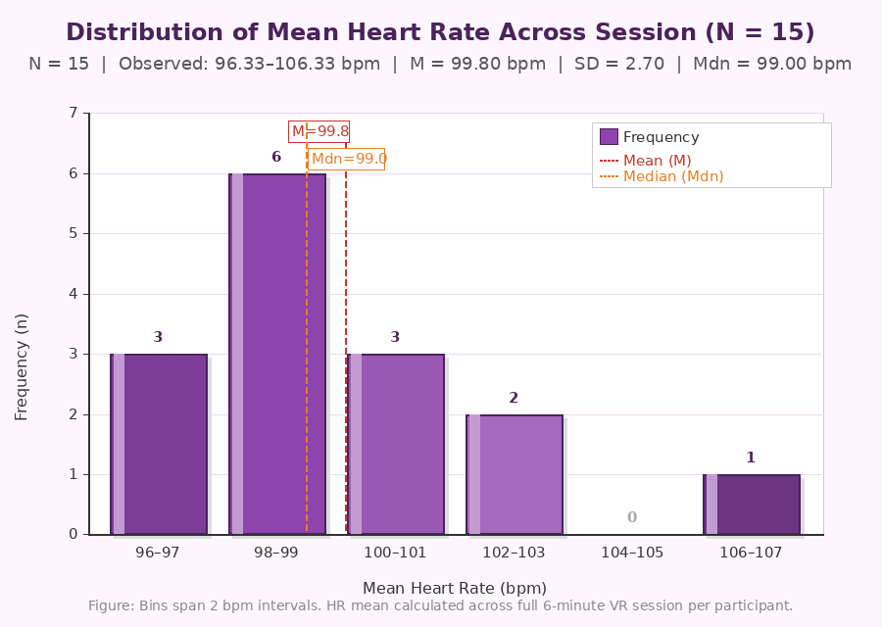
Figure 5• Figure 5.3: distribution of mean HR (bpm)

- Figure 5.4: distribution of dizziness ratings
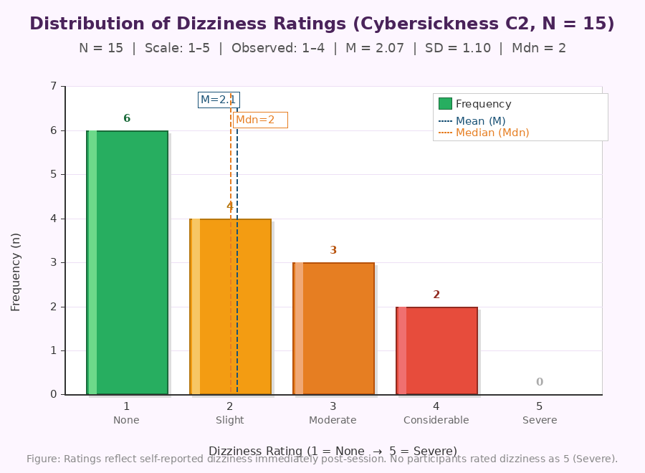
Figure 6• Figure 5.4: distribution of dizziness ratings

5.3.5 Interpretation of quantitative results (linked to literature)

Across the dataset, post-session PSS totals were low, and NA totals were near the lower bound, while PA totals were moderate to high. These patterns are directionally consistent with literature suggesting nature-like cues can support short-term stress reduction and improved mood (Gillis and Gatersleben, 2015; Kellert, 2008) and with broader feasibility evidence for VR-based wellbeing interventions (Park et al., 2019; Bell et al., 2024). However, because measures are post-only and follow a fixed two-scene sequence, this alignment should be interpreted as conceptual consistency rather than biome-specific causal evidence.
Comfort indicators were generally tolerable (low-to-moderate dizziness and low nausea/eyestrain). This matters because cybersickness can inflate stress or negative effect; collecting comfort indicators helps interpret whether any negative responses reflect content or medium-related discomfort. Presence scores suggest participants attended to the experience and reported a moderate sense of “being there,” supporting that the VR stimulus was meaningfully engaged with.

5.4 Qualitative feedback and observations

Post-session prompts asked how the experience felt (calm/discomfort) and whether the imagery felt sharp/comfortable. Responses were recorded as anonymized researcher notes rather than verbatim transcripts, so findings are presented as indicative thematic summaries, not as a full transcript-coded qualitative analysis.

5.4.1 Structured thematic condensation

Table 5.5: Thematic condensation of post-session debrief summaries (N = 15)
Caption: Composite paraphrases of debrief notes. Verbatim quotations are not included; themes are used to triangulate with the quantitative summaries rather than to claim causal inference.
Table 12 Table 5.5: Thematic condensation of post-session debrief summaries (N = 15)
Theme | Definition used when coding notes | Recurrent qualitative gist (composite) | Interpretive bridge
Calming tenor | Participant describes calm/relaxing/tranquil affect after the session. | Participants generally described the experience as calming, even when also critiquing visual fidelity. | Directionally consistent with low post-session PSS totals and low NA, but does not establish causality without baselines or controls.
Softness / blur of imagery | Participant reports blur/softness/lack of sharpness, often linked to distant detail (e.g., grass/water effects) or overall clarity. | Visuals were frequently described as “blurry” or “soft”, particularly for distant ground detail and fine foliage textures. | Aligns with documented Air Link streaming and LOD constraints; explains how calm ratings can co-exist with clarity complaints.

Interpretive stance. Qualitative condensation is used to triangulate and contextualize the descriptive statistics, not to substitute for controlled causal inference.

5.5 Discussion

5.5.1 Relating empirical patterns to cited literature

Descriptive summaries show low perceived stress totals, favorable positive effect, and low negative effect relative to scale ranges. These patterns are directionally consistent with biophilic/restorative accounts discussed in Chapter 2 and feasibility evidence in prior VR wellbeing work (Gillis and Gatersleben, 2015; Kellert, 2008; Park et al., 2019; Bell et al., 2024). However, those studies often use stronger designs (pre/post, control conditions, counterbalancing) than a single post-session composite score after two scenes. Therefore, the present results support feasibility and alignment rather than biome-specific conclusions.
Debrief notes indicate calm appraisals alongside frequent comments about softness or blur in visual detail. This is plausibly explained by a combination of streaming compression limits, LOD behavior, and performance trade-offs, which could reduce clarity without necessarily destroying the overall calm tone. Comfort results also need to be interpreted alongside known engineering artefacts (e.g., streaming frame pacing and interaction edge cases).
Heart-rate summaries were usable after preparation, but without a resting baseline they are interpreted as supportive context rather than as evidence of stress reduction.

5.5.2 Limitations: what conclusions are and are not supported

Key limitations that restrict inference:
- No biome-specific attribution: outcomes cannot be assigned uniquely to Garden versus Arctic because psychometrics was collected once after both scenes, and order was fixed.
- No pre/post change: without baselines, within-person stress/mood change is not measured.
- Convenience sample: recruitment from a friend’s group and the narrow age range limit generalizability.
- Streaming/performance confounds: frame pacing and compression artefacts may affect comfort, presence, and perceived clarity.
- Non-clinical scope: the work is feasibility-oriented and does not support clinical efficacy claims.

5.5.3 Implications for future iteration

Future work that would strengthen inference includes:
- counterbalancing or randomizing scene order,
- collecting per-scene measures or adding a baseline measure,
- repairing the grab/locomotion interaction regression and logging performance metrics (frame time) to quantify streaming artefacts,
- adding a resting HR baseline and standardizing the physiological window,
- recruiting beyond convenience sampling to broaden demographic variability.

CHAPTER 6: CONCLUSIONS AND FUTURE WORK

6.1 Conclusions

This project delivered two navigable UE5 VR scenes with deliberately contrasting biophilic cue density: an icy, visually austere Arctic environment and a more cue-rich domed horticultural MYFYP/Garden environment. Both were implemented with repeatable locomotion and overlapping interaction scaffolding (see Chapter 4) and evaluated under a short, feasible protocol with N = 15 participants using Meta Quest 2 PCVR streaming at 75 Hz.
Post-session descriptive results (Tables 5.1 to 5.3) and condensed debrief notes (Table 5.5) indicate that participants generally reported calm appraisals. Perceived stress totals clustered toward the low end of the PSS-10 scale (0–40), positive affect was moderate to high, and negative affect was relatively low. At the same time, participants almost universally reported that the visuals felt soft or blurry, consistent with documented streaming and rendering constraints.
These patterns are directionally consistent with restorative and VR wellbeing accounts discussed in Chapter 2, but the protocol design limits inferential strength. Specifically, the study uses one post-session measurement block after both environments, with a fixed order (Arctic first) and disclosed engineering artefacts (streaming frame pacing and interaction edge cases; see Section 4.4.6 and Section 5.5). Convenience sampling further limits generalizability.
The enduring contribution is therefore operational: complete authoring, exposure, and export pipeline with transparent limitation reporting. The work is explicitly feasibility-oriented rather than evidence of clinical therapeutic efficacy (as framed in Chapter 1).

6.2 Future work

Future extensions that would strengthen evidence and usability include:
- Larger and more diverse samples, potentially including participants with less VR experience and a wider age range.
- Repeated exposures and/or multi-session designs to examine whether effects persist beyond novelty.
- More robust tracking and richer behavioral markers (e.g., dwell time, movement patterns, optional interaction counts), stored separately from the core anonymized dataset.
- Improved administration tooling, such as automated session IDs, automatic export validation, and reduced manual transcription steps.
More specific methodological improvements:
- Control conditions: include a non-nature VR scene or a non-VR control to improve causal interpretation.
- Factor-isolation experiments: systematically vary single cues (e.g., audio on/off, water feature present/absent, lighting warmth) to identify which design elements matter most.
- Counterbalancing and per-scene measurement: randomize or counterbalance scene order and collect per-scene measures (or a baseline) to reduce order effects and enable stronger inference.
- Longitudinal designs: evaluate repeated sessions over weeks to explore durability (acknowledged as out of scope for a final-year schedule).
- Accessibility and inclusivity: evaluate with participants who have mobility constraints or sensory sensitivities and adapt comfort settings and UI accordingly.

6.3 Legal, Social, Ethical and Professional Issues

Legal (UK GDPR / data protection). The project followed core principles: informed consent, data minimization, secure storage, pseudonymization, and a defined retention/deletion approach.
Social. VR biophilic environments could expand access to restorative experiences for people with limited opportunity to access nature, offering a low-cost and repeatable wellbeing-support tool in non-clinical contexts.
Ethical. The evaluation prioritized VR safety and comfort, provided clear exit options, ensured withdrawal rights, and maintained a non-clinical framing to avoid overstating claims.
Professional. Professional practice includes academic integrity, transparent reporting, appropriate use of licensed assets, and responsible handling of participant data.
In practice, these issues translate into concrete choices: using participant IDs rather than names, limiting free-text fields to reduce accidental disclosure, keeping any contact information strictly for scheduling (not retained in the research dataset), and documenting asset licenses. Professional responsibility also requires honest reporting of limitations and negative findings without selective omission.

6.4 Synoptic reflections

This project strengthened a blend of technical and research skills. Technically, it involved configuring and maintaining a VR-capable Unreal project, balancing performance and comfort trade-offs, and implementing stable locomotion and interaction. On the research side, it required turning a broad topic (“VR for wellbeing”) into a feasible study protocol using validated measures and designing a data pipeline compatible with analysis and ethical constraints. These skills are relevant to roles in VR development, UX for immersive systems, and digital wellbeing technology where evidence and safety are as important as feature delivery.

REFERENCES

References are presented in Harvard (author–date) style (Nottingham Trent University / Cite Them Right conventions). Where multiple sources share the same organisational author, entries are ordered chronologically.
Equipment note. Empirical heart-rate values were recorded with a Coospo H808S chest strap. Polar H10 was not purchased for budget reasons; Polar Electro (2020) is cited only as background literature on chest-strap sensing quality.
Bell, I.H. et al. (2024) ‘Advances in the use of virtual reality to treat mental health conditions’, Nature Reviews Psychology, 3(8), pp. 552–567.
Cohen, S., Kamarck, T. and Mermelstein, R. (1983) ‘A global measure of perceived stress’, Journal of Health and Social Behavior, 24(4), pp. 385–396.
Gillis, K. and Gatersleben, B. (2015) ‘A review of psychological literature on the health and wellbeing benefits of biophilic design’, Buildings, 5(3), pp. 948–963.
Kellert, S.R. (2008) Biophilic Design: The Theory, Science and Practice of Bringing Buildings to Life. Hoboken, NJ: Wiley.
Park, M.J. et al. (2019) ‘A literature overview of virtual reality (VR) in treatment of psychiatric disorders: recent advances and limitations’, Frontiers in Psychiatry, 10, p. 505.
Polar Electro (2020) Polar H10 heart rate sensor white paper. Available at: https://www.polar.com/sites/default/files/static/science/white-papers/polar-h10-heart-rate-sensor-white-paper.pdf (Accessed: 29 April 2026).
Watson, D., Clark, L.A. and Tellegen, A. (1988) ‘Development and validation of brief measures of positive and negative affect: the PANAS scales’, Journal of Personality and Social Psychology, 54(6), pp. 1063–1070.
World Health Organization (2022) World mental health report: transforming mental health for all. Geneva: WHO.
World Health Organization (2025) Urban health. Available at: https://www.who.int/health-topics/urban-health/ (Accessed: 29 April 2026).

APPENDICES

APPENDIX A — Project planning evidence

This appendix provides documentary evidence of project planning and alignment with a time-bounded final-year workflow. The primary planning artefact is N1205091_PPD.pdf (Project Planning Document), which sets out the initial aim/objectives, tasks and deliverables, and an indicative month-by-month schedule.
A.1 Planning document (evidence)
- Document: N1205091_PPD.pdf (included with the submission package).
- Purpose: evidence of early scoping, milestones, resource assumptions, and deliverables.
A.2 Planned milestones and timeline (as stated in the planning document)
The planning document sets out a 7-month timeframe and an indicative schedule:
Table 13 The planning document sets out a 7 month timeframe and an indicative schedule:
Month | Milestone (planning document) | Intended deliverables (planning document summary)
1 | Project initiation | Literature review; tool selection; scope definition; proposal and initial Gantt chart
2 | Review point / specification | Finalize design specifications; begin prototype development; acquire software/tools
3–4 | Prototype development | Build VR environments; pilot testing; confirm environments meet requirements
4 | Participant recruitment | Recruit participants through social channels/flyers
5 | Testing phase | Run study; tabulate psychological and biometric data; log observations
5–6 | Data analysis | Analyze obtained data; create charts/graphs
6 | Demonstration | Live demonstration and documentation
7 | Thesis documentation | Final report compilation and submission
A.3 Scope and “out-of-scope” evidence from the planning document
The planning document explicitly excluded (among other items) clinical trials/medical certification and longitudinal studies beyond the 7-month window. This matches the dissertation’s non-clinical framing and the feasibility-oriented evaluation design.
A.4 Project risks (retrospective mapping to empirical work)
The planning document anticipated risks such as VR sickness, incomplete sensor capture, recruitment shortfalls, and privacy issues. In the implemented study, several of these risks occurred and are documented transparently:
- Comfort/performance risk: streaming-related artefacts (tearing / blur complaints) were recorded as an engineering limitation (Section 4.4.6) and reflected in debrief synthesis (Table 5.5).
- Sensor capture risk: heart-rate capture required preparation and stable Bluetooth connectivity; this is recorded as a measurement limitation (Section 4.4.6; Section 2.6.3).
- Recruitment risk: convenience sampling via social channels is documented (Section 5.2.1), with generalizability limitations discussed (Section 5.5).

APPENDIX B — Study materials

This appendix documents the instruments and prompts administered to participants. No written consent form was used; consent was obtained verbally (B.1). Standardized psychometric item sets were administered post-session (B.2 to B.3).
B.1 Verbal consent script (as administered)
Participants were provided with a brief verbal information summary before the session and asked for explicit verbal consent to proceed. The researcher confirmed each of the following points:
- Voluntary participation: participation is optional; participants can stop at any time without penalty.
- What the session involves: a short VR experience using joystick locomotion with optional object interaction; total VR exposure approximately 6 minutes (Arctic then Garden), followed by questionnaires.
- What data are collected: post-session questionnaire responses and heart-rate summaries (supportive metric), plus brief anonymous comments about comfort/visual quality.
- Scheduling only: a phone number may be exchanged only to arrange session times; it is not entered into the anonymized research spreadsheet and is not part of the study dataset.
- Anonymization: no names are recorded; only pseudonymous IDs (n001–n015) are used.
- Data use: anonymized results are used only for this final-year project dissertation and marking.
- Right to withdraw: participants can withdraw during the session; practical constraints after anonymization were explained if relevant.
- Safety: participants were advised to report dizziness/nausea; a researcher supervised sessions and could stop the session if required.

B.2 Perceived Stress Scale (PSS-10): items and scoring
The standard PSS-10 wording was used (Cohen, Kamarck and Mermelstein, 1983). Each item is rated on a 5-point frequency scale (0–4). Items 4, 5, 7, and 8 are reverse-scored.
Response options (0–4): 0 = Never; 1 = Almost never; 2 = Sometimes; 3 = Fairly often; 4 = Very often.
Scoring rule: reverse-score items 4, 5, 7, and 8 (0 becomes 4; 1 becomes 3; 2 stays 2; 3 becomes 1; 4 becomes 0), then sum all 10 items to produce a total score (0–40), where higher totals indicate higher perceived stress.
B.3 PANAS: items and scoring
The standard PANAS wording was used (Watson, Clark and Tellegen, 1988). Items are rated on a 5-point intensity scale.
Response options (1–5): 1 = Very slightly or not at all; 2 = A little; 3 = Moderately; 4 = Quite a bit; 5 = Extremely.
Scoring rule: sum PA items (10–50) and sum NA items (10–50).
B.4 Additional post-session comfort / presence items (project-specific)
Alongside PSS/PANAS, the study recorded brief single-item ratings used to contextualize comfort and perceived realism. These are not presented as validated standalone instruments; they are reported descriptively (Chapter 5):
- Presence P1 (“really there”, 1–5)
- Presence P2 (believable, 1–5)
- Presence P3 (attention, 1–5)
- Cybersickness C1 (nauseous, 1–5)
- Cybersickness C2 (dizzy, 1–5)
- Cybersickness C3 (eyestrain, 1–5)
- Sound clarity A1 (clear audio, 1–5)

APPENDIX C — Data schema and anonymization

This appendix documents the final dataset schema and anonymization approach. The canonical analysis-ready dataset is biophilic_vr_data_entry_cleaned.csv (15 rows).
C.1 Participant ID strategy
- Participants are represented using pseudonymous IDs (n001–n015).
- No names are stored in the analysis CSV.
C.2 Dataset column dictionary (canonical CSV)
Table 14 Dataset column dictionary (canonical CSV)
Column | Type | Description
participant_id | string | Pseudonymous participant identifier (n001…n015).
session_date | string | Session date as recorded (e.g., “30th January,2026”).
start_time | string | Session start time label (e.g., “10:00”).
duration_min | number | Total cumulative VR biome exposure (minutes) for the recorded session (6 = 3 min Arctic + 3 min MYFYP/Garden, fixed order).
headset_refresh_hz | number | Headset refresh rate used (Hz), recorded per session (e.g., 75).
pss1…pss10 | integer (0–4) | Raw PSS-10 item responses (0 = Never … 4 = Very often).
pss_total_scored_correct | integer (0–40) | PSS total computed with reverse-scoring of items 4, 5, 7, and 8.
pa_total_correct | integer (10–50) | Positive Affect total (sum of PA items).
na_total_correct | integer (10–50) | Negative Affect total (sum of NA items).
presence_p1_really_there | integer (1–5) | Presence rating (“really there”).
presence_p2_believable | integer (1–5) | Believability rating.
presence_p3_attention | integer (1–5) | Attention/engagement rating.
cyber_c1_nauseous | integer (1–5) | Nausea rating.
cyber_c2_dizzy | integer (1–5) | Dizziness rating.
cyber_c3_eyestrain | integer (1–5) | Eyestrain rating.
sound_a1_clear_audio | integer (1–5) | Perceived audio clarity rating.
hr_start_bpm | number | Heart rate at start of the recorded window (bpm).
minimum_bpm | number | Minimum heart rate observed (bpm).
hr_peak_bpm | number | Peak heart rate observed (bpm).
hr_end_bpm | number | Heart rate at end of the recorded window (bpm).
hr_mean_bpm | number | Mean heart rate across the recorded window (bpm).

C.3 Heart-rate workflow (Coospo H808S)
- Device: Coospo H808S chest-strap heart-rate monitor.
- Acquisition: Bluetooth pairing to a recording device/app; values were then entered into the spreadsheet (start/min/peak/end/mean).
- Data minimization: intermediate app logs were not retained after recording values into the spreadsheet.
C.4 Storage, identifiers, and phone-number handling
- Storage: the analysis CSV was stored in a private local/OneDrive workspace and treated as confidential coursework material.
- Identifiers in the dataset: the analysis CSV contains no names and uses only participant_id.
- Phone numbers: used only for arranging session times; not recorded in the research CSV and not linked to pseudonymous IDs in any stored analysis file.
C.5 Retention and deletion
- Retention: pseudonymous analysis data retained until dissertation submission and marking completion as required.
- Deletion: scheduling-only contact details removed once no longer required; intermediate app logs follow the approach in Section C.3. Analysis exports are deleted or archived per university guidance after assessment.

